Pocket Orchards update 2022 by John Wood

A ‘pocket orchard’ is a small group of community fruit trees which are accessible, where possible, to local residents with no, or minimum driving. The inspiration came from the community orchard in the garden of Cromarty Courthouse Museum, the wonderful gardens at Inverewe, and noticing some neglected apple trees in an overgrown corner of Poolewe.
Apart from fruit, the orchards are intended to provide spaces and spring blossom to lift people’s spirits, create some hope for the future, and encourage pollinators. The basis of the idea is that people and the planet cannot be separated and must work together for mutual benefit. We aim to build an abundance of resources for both people and the planet in a landscape that has been so badly damaged over the last 200 years. Food production is therefore only one of several objectives.
So far, the pocket orchards project has planted 250 fruit trees in Wester Ross, across 32 sites. Nine of these sites have been planted at or in conjunction with local schools – Ullapool and Plockton High Schools, and Badcaul, Balnaluib, Poolewe, Kinlochewe, Shieldaig and Applecross primaries. We hope to add trees at Lochcarron and Gairloch primary schools next year.
The biggest orchard so far is at Gairloch High School with 37 trees; the smallest is a single tree, trained on the wall of Bridge Cottage cafe in Poolewe (the original tree, planted in the winter of 2016/7).
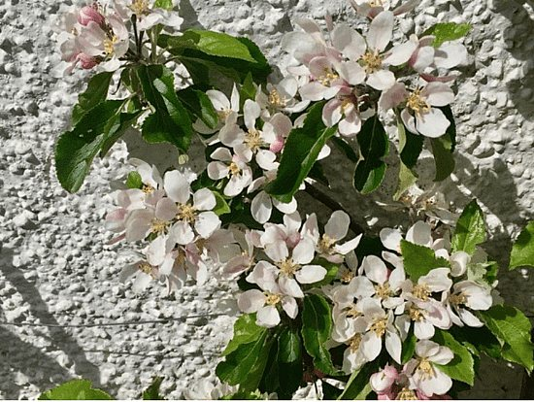
Blossom, spring 2021 on the original tree in Poolewe. This tree (Katy) started to produce crops of apples in 2020.
Other sites where the pockets orchards can be found include Old Inverasdale school, now a community owned building, Torridon and Gairloch Youth Hostels, Poolewe Village Hall, Laide Community Wood (2 sites), Inverewe (NTS), Kinlochewe church, St Maelrubha’s church Poolewe, Ullapool allotments, and on public amenity land at Laide, Autbea, Poolewe, Gairloch, Badachro and Kinlochewe.
The school’s orchards already provide educational benefits. In due course, there will also be social activities and training in tree propagation and care, building a local skills base and creating opportunities for community-focussed events and activities that will help bring people together and help build confidence.
Local people will be able to harvest the fruit to make jam, pies, and more. Beekeepers will benefit from increased yields of honey, and a revived insect population will pollinate other plants and trees, building biodiversity more widely. Perhaps the presence of the trees will inspire crofters and others to start growing trees themselves and provide a basis for a small but circular and sustainable economy.
The majority of the trees are apples, of varieties carefully chosen to suit Wester Ross conditions with a focus on non-commercial ‘heritage’ varieties. There are also plums, pears, cherries, cornelian cherries, cherry plums, two chestnuts and a walnut. The main suppliers have been Andrew Lear in Perthshire and John Hancox in Glasgow. There have also been individual donations of trees.
The project is currently taking stock of progress so far but the intention is to resume planting in 2022, both expanding existing orchards and establishing new ones. Key plans for 2022 also include completing a delayed grafting workshop on a croft near Poolewe which marks the start of the propagation of endangered old local varieties. We also hope to build community engagement through a volunteer network. The plan is to move towards more locally grown trees from local stock. Perhaps in the longer term there might be opportunities to start developing new varieties that are both productive and resilient in Wester Ross conditions.
The project has been able to go ahead thanks to the project founders, those who donated to the crowdfunder, the Highland Council’s Ward Discretionary Fund, The Pebble Trust, the Woodland Trust, TCV, Ovo Energy and other, private, donors.

